
Final Project Report

Course Title: Software Engineering Design Capstone Project
Course Code: SE 311
────────────────────────────────────────────────────────
SUBMITTED TO:
Md. Rashedul Alam
Lecturer
Department of SWE
Daffodil International University

SUBMITTED BY:
MD. Shoaib Sikder - 024231005341157
Section: 40_G2
Department of SWE
Daffodil International University

Scholars Canvas
Project Documentation

Table of Contents
1. Executive Summary..................................................3
2. Introduction.......................................................4
3. Scenario Writing...................................................5
4. Requirement Specification..........................................8
5. System Design & Architecture.......................................10
6. Technical Implementation...........................................21
7. Quality Assurance & Testing........................................26
8. Individual Contribution............................................28
9. Conclusion & Future Work...........................................29
10. Appendices........................................................30

List of Figures
- Figure 1: System architecture
- Figure 2: Illustrative interface overview
- Figure 3: Role-based route protection
- Figure 4: Use case model
- Figure 5: AI study document pipeline
- Figure 6: Course resource workflow
- Figure 7: Task and study workflow
- Figure 8: Communication workflow
- Figure 9: Notification workflow
- Figure 10: Administration workflow
- Figure 11: Logical database model (ERD)
- Figure 12: Application data flow

List of Tables
- Table 1: Functional requirements
- Table 2: Non-functional requirements
- Table 3: Scenario catalogue
- Table 4: Logical data dictionary
- Table 5: API overview
- Table 6: RBAC matrix
- Table 7: Test case scenarios
- Table 8: Requirements traceability matrix
- Table 9: Environment configuration
- Table 10: Future enhancement roadmap

1. Executive Summary
Scholars Canvas is a full-stack, role-based academic productivity platform designed to bring routine planning, task tracking, course resources, AI-assisted study, communication, notifications, search, and administration into a single web application. The repository describes the system as an “Academic Command Center” and separates the experience into a normal-user workspace for students and a dedicated administration workspace for staff, moderators, and system managers.
The platform addresses a practical fragmentation problem in student life. Academic resources may be spread across PDFs, slides, cloud links, notes, messaging tools, calendars, and separate AI assistants. Scholars Canvas combines these workflows so that a student can organize courses and resources, plan weekly routines, create tasks, record study sessions, process study documents through an AI Lab, communicate with classmates, and receive contextual notifications without switching between unrelated systems.
A central design goal is role separation. The repository documents protected normal-user routes and admin-only routes, while the backend provides separate API namespaces. Administrative capabilities include user management, resource moderation, AI usage controls, communication moderation, announcements, analytics, system settings, audit logs, and aggregate task/routine oversight.

Technology Stack
Layer | Technology | Primary Role
Frontend | React 19 + Vite 7 | Single-page application and UI composition
Routing / UI | React Router 7 + Tailwind CSS 4 | Route management and responsive styling
Interaction | Framer Motion + Lucide React | Motion and iconography
Backend | Django 6 + Django REST Framework | Authentication, APIs, business logic
Real-time | Django Channels + Daphne | WebSocket-capable communication architecture
Database | PostgreSQL | Relational persistence
Storage | Supabase Storage | Study materials and media storage
Email | Resend | Email delivery workflows
AI | Groq / OpenRouter | Configurable AI providers/models
Document processing | pypdf, pdfplumber, PyMuPDF, python-docx, python-pptx, openpyxl, pytesseract, BeautifulSoup | Extraction, parsing, OCR, and document preparation

Key Outcomes
- Unified academic workspace covering dashboard, routine, tasks, resources, AI study tools, communication, notifications, profile, and settings.
- Role-aware routing and backend protections that keep administrative capabilities separated from normal student workflows.
- AI-assisted study flow that can create summaries, quizzes, MCQs, and document conversations from uploaded or Vault-managed material.
- Admin control layer for moderation, access control, analytics, system settings, announcements, and audit history.
- Modular backend and domain-oriented frontend structure intended to support feature growth without collapsing all functionality into one code area.
Repository verification note: the public README provides explicit setup and verification commands, but it does not provide automated test reports or a complete execution history for every feature. Accordingly, the Quality Assurance chapter distinguishes between documented verification procedures, test scenarios, and evidence actually present in the repository.

2. Introduction

2.1 Problem Statement
University students frequently manage the same academic information across multiple disconnected tools: a timetable or personal calendar, a task list, local folders, cloud drives, group messaging, and one or more AI tools. This separation creates repeated data entry, makes study materials difficult to locate, and weakens the connection between planned activities and actual study progress. Communication, reminders, resources, and AI-assisted learning are also usually treated as separate services.
Scholars Canvas proposes a unified student workspace in which the core academic objects are connected. Courses can contain resources; resources can become inputs to the AI Lab; tasks and study sessions contribute to progress tracking; routines provide scheduled context; notifications communicate system changes; and communication features support collaboration among normal users. A second workspace gives authorized administrators control over users, resources, AI usage, communication, announcements, analytics, system settings, and auditability.

2.2 Project Objectives
- Build a secure full-stack academic productivity platform using React and Django-based APIs.
- Provide role-aware authentication and routing for normal users and administrators.
- Centralize courses and study resources with metadata, storage controls, and search.
- Provide routine planning, task management, study sessions, deadlines, and progress-oriented analytics.
- Integrate an AI Lab for summaries, quizzes, MCQs, and document-grounded chat.
- Provide student-to-student communication through friend relationships, one-to-one conversations, group conversations, messages, and attachments.
- Provide in-app notifications and configurable announcements, including targeted announcements by university, department, or semester.
- Provide administration, moderation, analytics, system settings, and audit logs with backend enforcement.
- Keep the codebase modular across backend apps and frontend feature folders so that future modules can be added without redesigning the entire system.

2.3 System Boundaries / Scope
In-Scope | Out-of-Scope / Not Evidenced
Authentication, registration, password reset, profile and preferences | University ERP / attendance integration
Dashboard, routines, tasks and study sessions | Native mobile application
Course Vault and resource uploads/metadata | Offline-first synchronization / PWA
AI Lab document processing, summaries, quizzes, MCQs and chat | Guaranteed external cloud-drive synchronization
Friends, friend requests, 1:1 and group conversations, attachments | Payment processing or commercial billing
Notifications, announcements and search | Evidence of production-grade automated test coverage
Admin user/resource/AI/communication controls, analytics, settings, reports and audit logs | Detailed performance/SLA measurements not present in repository evidence

2.4 Stakeholder Analysis
Stakeholder | Needs / Interests | System Responsibilities
Normal User / Student | Organize study life and collaborate | Dashboard, routine, tasks, Vault, AI Lab, communication, notifications, profile, settings
Administrator | Maintain platform health and control policy | User management, moderation, AI controls, analytics, announcements, settings, audit logs
Developer / Maintainer | Maintain modular, testable, extensible code | Domain-separated backend apps, frontend feature folders, API layer, environment configuration
Service Providers | Support storage, email and AI capabilities | Supabase Storage, Resend, Groq/OpenRouter
Academic Department / Institution | Potential future institutional usage | Future integration, policy and governance layer; not directly implemented in the current scope

3. Scenario Writing

Scenario-1: User Registration, Login and Role-Aware Redirection
- Entry: A visitor opens the authentication interface and submits registration or login information.
- Validation: The backend validates credentials and account status and returns an authentication token when login succeeds.
- Profile Resolution: The frontend loads the current user profile and determines whether the account belongs to the normal-user or administrative workspace.
- Routing: Normal users are routed to the student workspace; authorized staff/admin accounts are routed to administrative routes; unauthorized or inactive states are blocked.
- Outcome: A persistent authenticated session is maintained in the application until logout or forced session termination.

Scenario-2: Weekly Routine Planning
- Entry: A normal user opens the Routine module.
- Input: The user creates or updates routine slots with time/day-aware academic information.
- Validation: The system validates the submitted routine data and reports status or validation feedback.
- Presentation: The UI can present grid/list views and a current-class banner.
- Outcome: Routine information becomes available to the dashboard and aggregate study-planning context.

Scenario-3: Task Creation and Study Tracking
- Entry: The user creates an assignment, reminder, or study task.
- Input: Title, course context, priority, deadline, description and status information are maintained.
- Workflow: Tasks can be viewed in table/list form or a Kanban-style workflow.
- Study Session: The user records study sessions related to work and updates progress.
- Outcome: Task and study-session activity contributes to dashboard statistics and analytics.

Scenario-4: Course and Resource Vault Management
- Entry: The user opens a course workspace or creates a course.
- Input: A resource is uploaded or registered with metadata such as type, size, course and ownership.
- Policy Check: The application applies configured upload and allowed-extension rules.
- Storage: The file is stored using the configured media layer, while resource metadata is persisted by the backend.
- Outcome: The resource becomes available through the Vault and can be selected for AI processing.

Scenario-5: AI Document Preparation from Vault
- Entry: The user selects an existing Vault resource or uploads a study document directly to the AI Lab.
- Processing: The backend identifies the file format and extracts content using configured document libraries; OCR can be used where required.
- Preparation: Extracted material is normalized into an AI-document context.
- Provider: The configured AI provider/model is selected according to current system settings and provider fallback behavior.
- Outcome: The document is ready for summary, quiz, MCQ, or grounded chat workflows, with processing status and AI logs maintained.

Scenario-6: AI Summary, Quiz, MCQ and Document Chat
- Entry: A processed AI document is opened in the AI Lab.
- Action: The user chooses summary generation, quiz generation, MCQ generation or chat over the selected study material.
- Execution: The backend submits the task to the configured AI service.
- Resilience: Provider/model fallback logic can be used when the primary path cannot complete the request.
- Outcome: The generated content is displayed in the AI Lab and relevant request/result status is logged.

Scenario-7: Friendship and Communication
- Entry: A normal user searches for another normal student account.
- Request: The user sends a friend request; the recipient may accept, reject or the sender may cancel it.
- Access: Friendship is established only for accepted relationships.
- Conversation: Users can use one-to-one conversations and can create group conversations within the documented friend-only restriction.
- Messaging: Text and file messages can be sent; users can edit or unsend their own messages; message events generate notifications.

Scenario-8: Notification Generation and Announcements
- Trigger: A message, system event, moderation event or administrator announcement creates a notification condition.
- Creation: The backend creates a notification record with source/target context and unread state.
- Delivery: The user sees the notification through the application notification panel; configured email delivery can also be used.
- Targeting: Administrators can issue system-wide or targeted announcements based on university, department or semester.
- Outcome: Users can load more notifications and mark individual notifications as read.

Scenario-9: Global Search / Command Bar
- Entry: A user opens the global search/command interface using the normal search control or Ctrl+K.
- Context: The search mode is aware of the current workspace and role.
- Retrieval: The application searches pages/resources available to that role.
- Navigation: Selecting a result opens the correct application route or resource.
- Outcome: Search reduces navigation cost without allowing users to surface routes outside their permitted workspace.

Scenario-10: Administrator User and Access Management
- Entry: An authorized administrator enters the admin workspace.
- Retrieval: The system loads user-management data and allows searching/filtering of users.
- Administrative Actions: Administrators can create users, change role/access, suspend/unsuspend users, force logout, and toggle AI or messaging access.
- Enforcement: Frontend controls are supported by backend restrictions, and audit history records administrative/security actions.
- Outcome: Account access can be changed centrally without giving normal users access to admin endpoints.

Scenario-11: Resource / AI / Communication Moderation
- Entry: Admin selects a resource, AI document, conversation or message from a moderation area.
- Inspection: The admin views metadata, status and moderation context.
- Decision: Content or access can be flagged, removed, restored, revoked, or communication can be disabled/enabled.
- Report Handling: Moderation reports can be reviewed, resolved or dismissed.
- Outcome: Moderation state changes are auditable and can generate notifications where appropriate.

Scenario-12: System Settings and Audit Oversight
- Entry: Administrator opens System Settings or Audit Logs.
- Settings: Registration availability, maintenance mode, upload limits, allowed extensions, AI provider/model behavior, rate limits and group-chat limits can be configured through admin endpoints.
- Audit: The administrator reviews actor, role, action, target and timestamp information.
- Privacy: Task/routine oversight is described as aggregate and privacy-preserving instead of exposing personal task content by default.
- Outcome: Platform-level behavior is centrally controlled and major security/moderation events remain traceable.

4. Requirement Specification

4.1 Functional Requirements
ID | Feature | Requirement | Stakeholder
FR01 | User Registration | Create a normal user account with university profile information. | User
FR02 | User Login | Authenticate with token-based login and maintain authenticated state. | User/Admin
FR03 | Password Reset | Request and confirm password reset. | User
FR04 | Profile Management | Load and update profile information and visibility preferences. | User
FR05 | Role-Aware Redirect | Route users to normal-user or admin workspace based on role/status. | User/Admin
FR06 | Student Dashboard | Present academic overview, tasks, deadlines, recent resources and study analytics. | User
FR07 | Routine Planner | Create, update and delete weekly routine slots. | User
FR08 | Task Management | Create and update assignments, reminders and study tasks. | User
FR09 | Study Sessions | Record study sessions and connect them to task/progress context. | User
FR10 | Course Management | Create and manage course-level Vault workspaces. | User
FR11 | Resource Upload | Upload and manage course resources and metadata. | User
FR12 | Resource Search | Search and open available study resources from the application. | User
FR13 | AI Document Intake | Upload or create AI documents from Vault resources. | User
FR14 | AI Summary | Generate summaries from selected study material. | User
FR15 | AI Quiz | Generate quizzes from selected study material. | User
FR16 | AI MCQ | Generate multiple-choice quizzes. | User
FR17 | Document Chat | Ask questions grounded in selected study material. | User
FR18 | AI Administration | Monitor AI documents, requests, providers/models, failures and access. | Admin
FR19 | Student Search | Search for normal student users for communication. | User
FR20 | Friend Requests | Send, accept, reject and cancel friend requests. | User
FR21 | Friendship Management | Maintain a friend list for communication. | User
FR22 | Conversations | Create one-to-one and eligible group conversations. | User
FR23 | Messaging | Send, edit and unsend text/file messages under communication rules. | User
FR24 | Notifications | Display unread counts, load more records and mark notifications as read. | User
FR25 | Announcements | Send system-wide and targeted announcements. | Admin
FR26 | Global Search | Search application pages/resources with role-aware results. | User/Admin
FR27 | User Administration | Search, create, suspend, unsuspend and modify users. | Admin
FR28 | Resource Moderation | View, flag, remove, restore and revoke resource access. | Admin
FR29 | Communication Moderation | Review conversations/messages and enable/disable or remove/restore content. | Admin
FR30 | Moderation Reports | Review, resolve and dismiss reports. | Admin
FR31 | Analytics | View feature, upload, AI and weekly platform metrics. | Admin
FR32 | System Settings | Configure registration, maintenance, uploads, AI, rate limits and group chat limits. | Admin
FR33 | Audit Logs | Review security and admin actions with actor and timestamp context. | Admin
FR34 | Privacy-Preserving Oversight | Provide aggregate task/routine statistics without routine exposure of personal task content. | Admin
FR35 | Workspace Access Control | Prevent normal users from accessing admin routes/APIs and prevent admin accounts from using normal communication APIs. | User/Admin

4.2 Non-Functional Requirements
ID | Category | Requirement
NFR01 | Security | Authentication, route guards and backend authorization must enforce workspace boundaries.
NFR02 | Usability | The normal-user workspace should minimize navigation cost through shared shell, search and contextual dashboards.
NFR03 | Maintainability | Backend functionality should remain separated by domain apps and frontend functionality by feature folders.
NFR04 | Scalability | The architecture should allow additional modules, AI providers, resources and admin policies without redesigning the whole application.
NFR05 | Availability | The application should fail gracefully when optional external services such as AI/email are unavailable.
NFR06 | Performance | Large AI/document tasks should not unnecessarily block the interactive UI; the project description emphasizes decoupled/async processing.
NFR07 | Privacy | Administrative task/routine oversight should use aggregate data rather than exposing personal content by default.
NFR08 | Auditability | Security and administrative actions should remain reviewable through audit history.
NFR09 | Configurability | Upload limits, allowed extensions, AI providers/models and rate limits should be centrally configurable.
NFR10 | Accessibility | Interface structure should support readable hierarchy, keyboard navigation patterns and reduced-motion preference.
NFR11 | Portability | The application should run using the documented Python/Node/PostgreSQL prerequisites and should support standard browser clients.
NFR12 | Observability | AI failures, usage trends, reports and audit records should be visible to authorized administrators.

4.3 Requirement Prioritization
Priority | Examples | Reason
Critical | Authentication, RBAC, resource ownership, admin controls, database persistence | Without these the platform cannot safely operate.
High | Tasks, routine, Vault, AI Lab, communication, notifications | Core user value of the application.
Medium | Analytics, search refinements, targeted announcements, moderation analytics | Enhances platform operation and discoverability.
Future | PWA/offline, group project hubs, external drive sync, institutional integrations | Listed or implied future expansion areas rather than current core scope.

5. System Design & Architecture

5.1 System Architecture Diagram
The architecture follows a layered full-stack pattern. The React/Vite client is separated from the Django application layer. Backend apps are organized around business domains, while PostgreSQL provides relational persistence and Supabase Storage handles uploaded study materials/media. AI and email capabilities are treated as external service integrations. Django Channels/Daphne provide the real-time communication foundation.
Figure 1: Scholars Canvas layered system architecture derived from the repository technology and module structure.
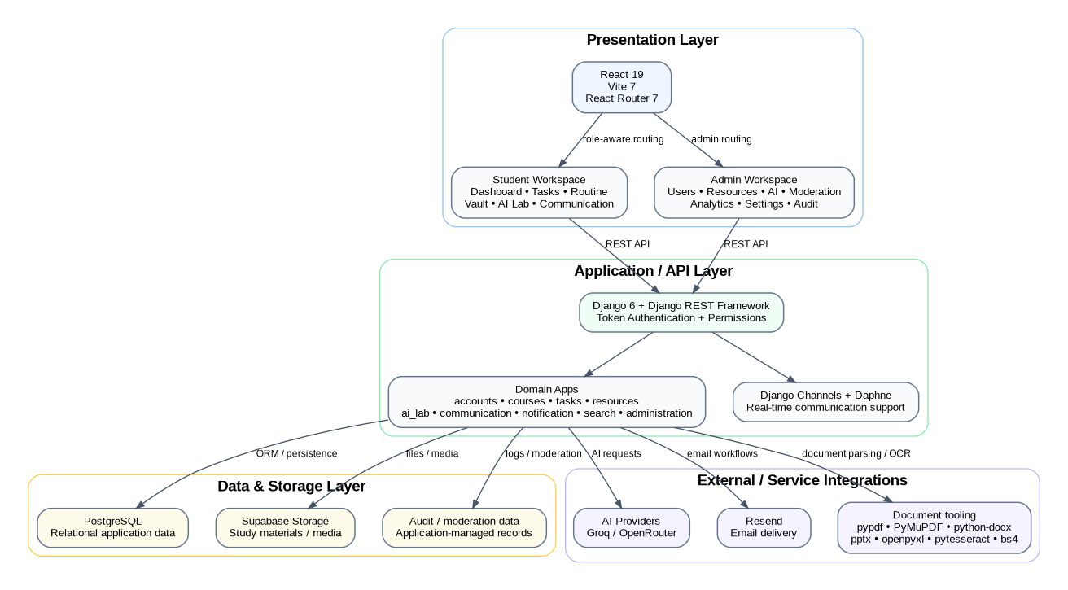

5.2 Illustrative Interface Overview
The following figure is an illustrative documentation mockup generated from the repository feature set. It is not presented as a literal screenshot of the current deployed UI; it visually summarizes the documented student and administration workspaces so that the academic report contains a readable interface figure alongside the structural diagrams.
Figure 2: Illustrative student and admin workspace overview based on documented Scholars Canvas features.
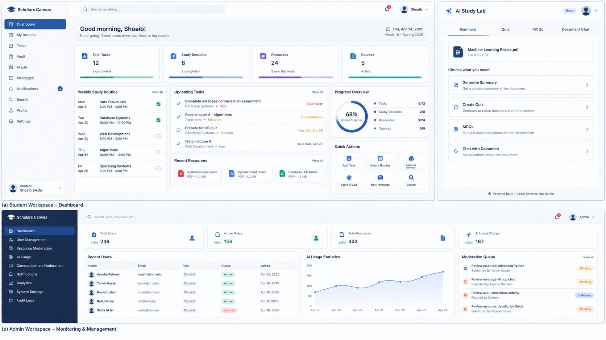

5.3 Role-Based Routing Model
The repository explicitly separates normal-user and admin routes. The ProtectedRoute layer is described as supporting user-only and admin-only access, authentication requirements, and profile-loading guards. Admin users include Django is_staff/is_superuser plus application-level admin role metadata such as support_admin, moderator and super_admin.
Figure 3: Role-aware authentication, workspace routing and access-denial flow.
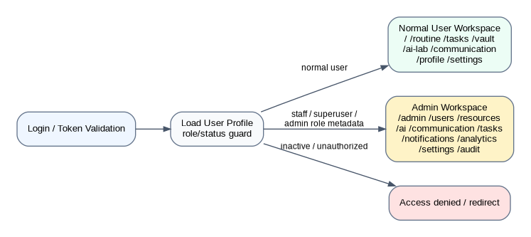

Figure 4: 5.4 Use Case Model - high-level interactions for normal users and administrators.
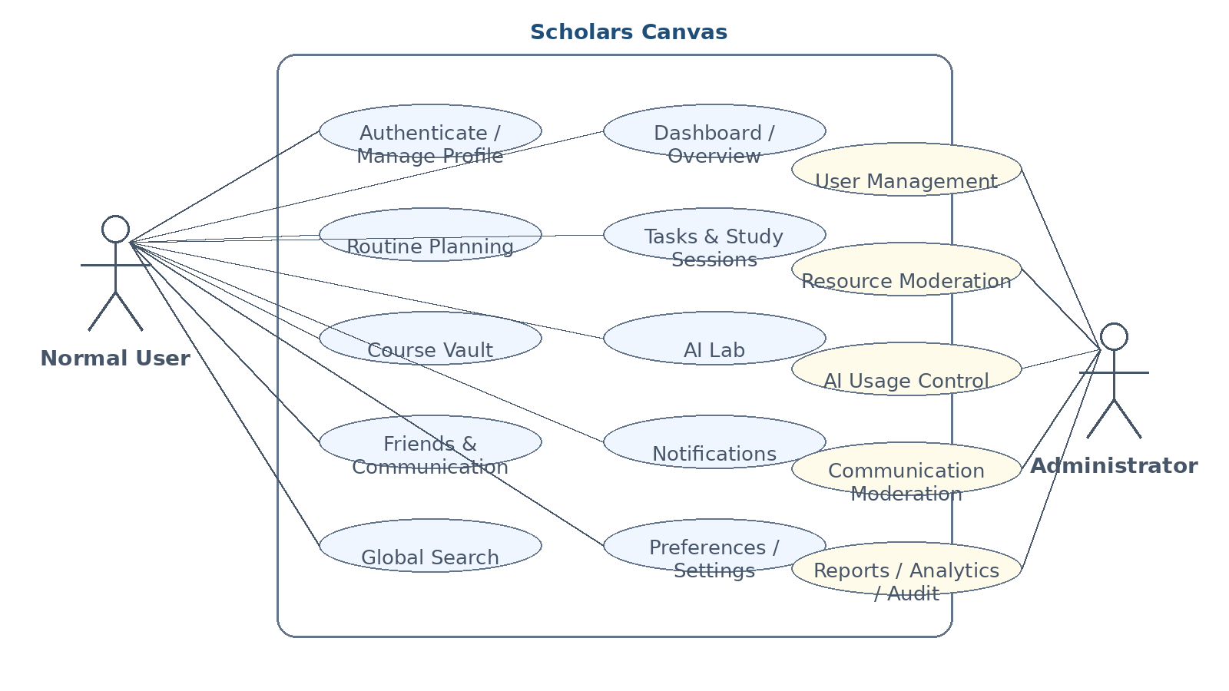

5.5 Activity Diagrams
5.5.1 AI Study Document Processing - Figure 5: AI document ingestion, processing, generation and logging flow.
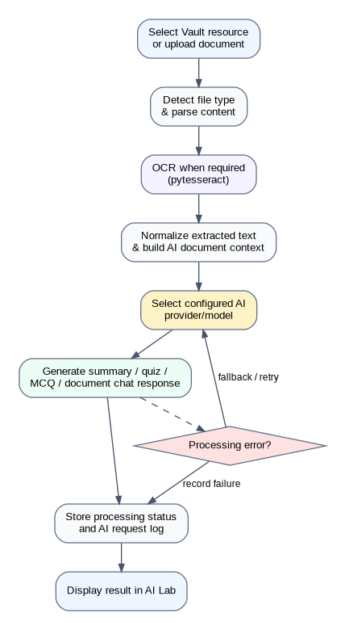

5.5.2 Resource Vault Workflow - Figure 6: Course resource creation, validation, storage and AI handoff.
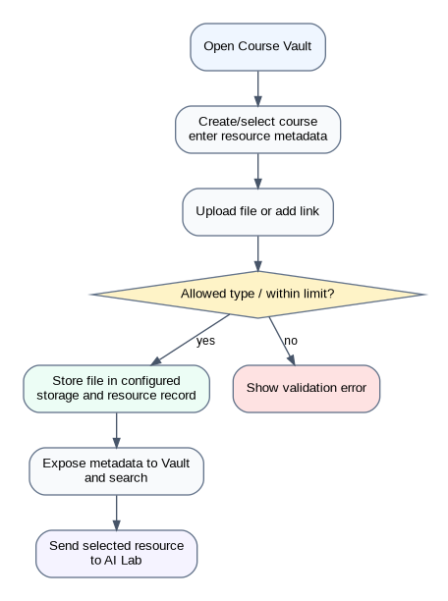

5.5.3 Task and Study Workflow - Figure 7: Task creation, Kanban/list tracking, study sessions and analytics.
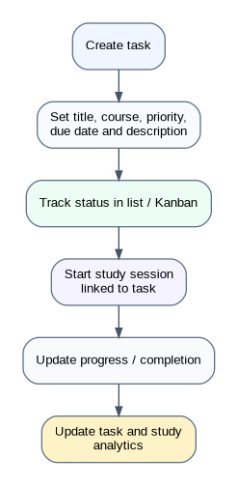

5.5.4 Communication Workflow - Figure 8: Friend request, friendship and message lifecycle.
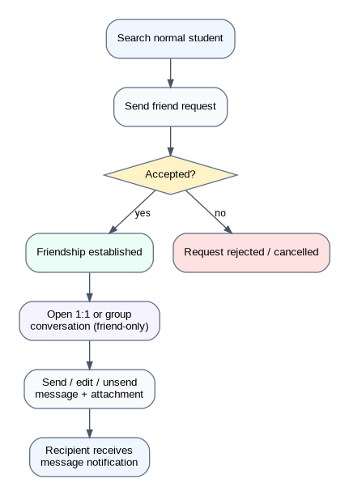

5.5.5 Notification Workflow - Figure 9: Notification creation, delivery preferences, read state and optional email delivery.
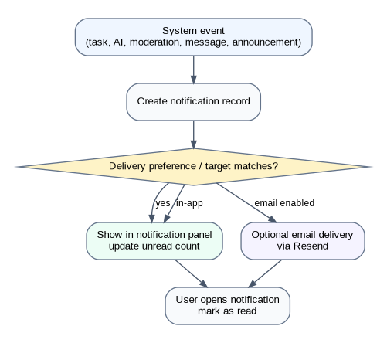

5.5.6 Administration Workflow - Figure 10: Administrative inspection, policy action, notification and audit trail.
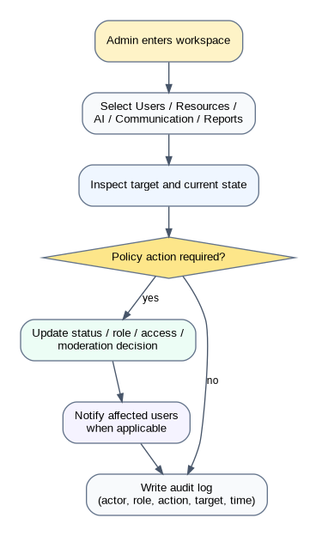

5.6 Database Design
The repository README exposes the logical domains and capabilities but does not publish a full field-level schema in the available public README. Therefore the following ERD is a logical database model for documentation purposes, built from the documented backend apps and feature relationships. Exact migration field names and SQL data types should be checked against the repository migrations before treating this as a database contract.
Figure 11: Logical entity relationship model derived from documented Scholars Canvas domains; exact physical schema requires migration-level verification.
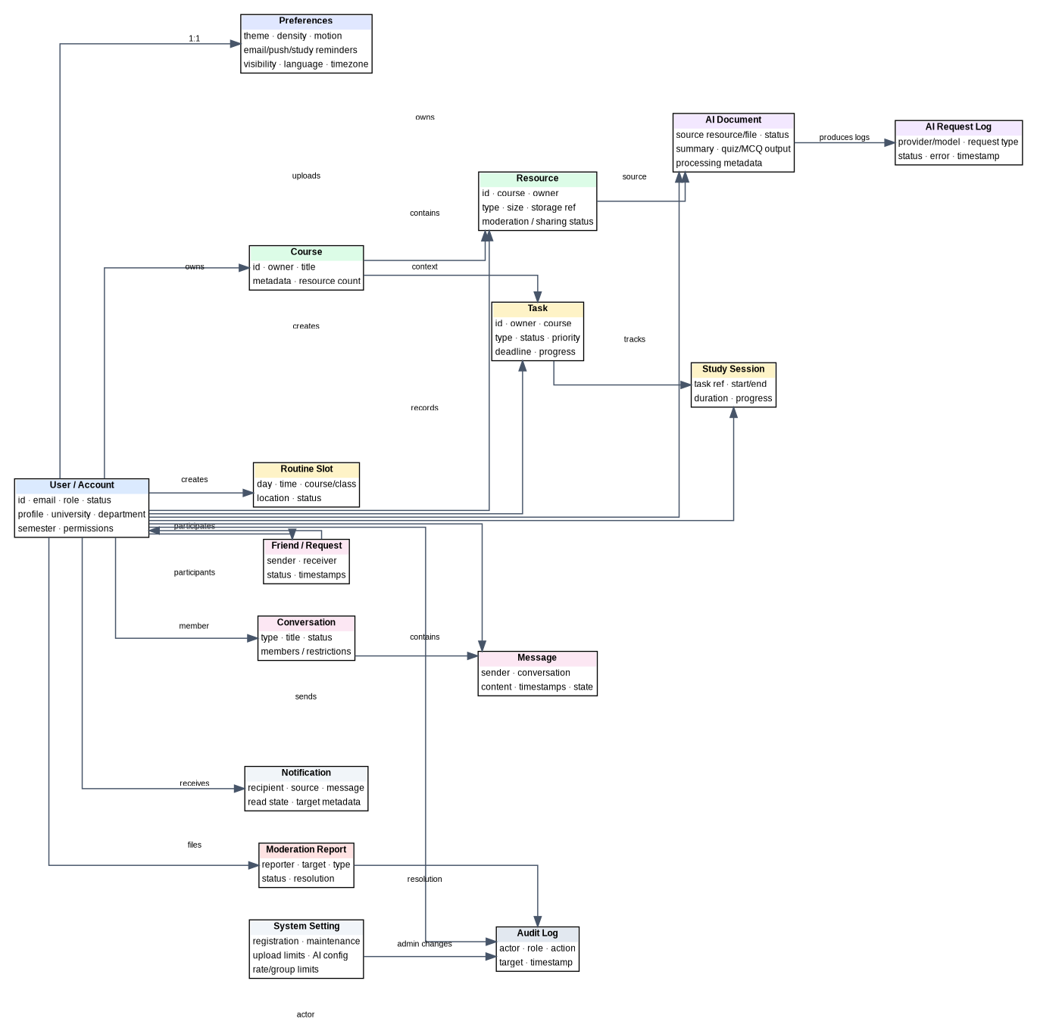

5.6.1 Logical Data Dictionary
Entity | Key Fields / Attributes | Logical Type | Relationship / Notes
User / Account | id, email, role, status, profile, university, department, semester | Identifier + text + status flags | Central identity object; referenced by most user-owned domains.
Preferences | theme, compact mode, reduced motion, email/push/study reminders, visibility, language, timezone | Setting fields | One logical preference profile per user.
Course | id, owner, title, metadata | Identifier + text | Course groups resources and provides academic context.
Resource | id, course, owner, type, size, storage reference, moderation/sharing status | Identifier + metadata | Stored media is linked to a course and owner.
Task | id, owner, course, type, title, status, priority, deadline, progress | Identifier + workflow fields | Used by dashboard, task, analytics and study-session features.
Routine Slot | day, time, course/class, location, status | Schedule fields | Belongs to a normal user.
Study Session | task reference, start/end, duration, progress | Time + numeric progress | Connects effort tracking to tasks/analytics.
AI Document | source resource/file, processing status, generated artifacts/context | Identifier + long text/status | Created from Vault resources or direct AI uploads.
AI Request Log | provider, model, request type, status, error, timestamp | Log fields | Administrative visibility into AI usage and failures.
Friend / Request | sender, receiver, state, timestamps | Relationship + status | Controls who may participate in student communication.
Conversation | type, title, members, moderation state | Identifier + status | One-to-one or eligible group chat.
Message | conversation, sender, content, timestamps, state | Long text + metadata | Supports edit/unsend and attachments.
Notification | recipient, source, message, unread/read state, target metadata | Text + status | Used for in-app notification panel and announcement delivery.
Moderation Report | reporter, target, type, status, resolution | Identifier + status | Admin review/resolve/dismiss lifecycle.
System Setting | registration, maintenance, upload limits, allowed extensions, AI configuration, rate limits | Configuration values | Central platform policy controls.
Audit Log | actor, role, action, target, timestamp | Immutable-style log record | Security/admin traceability and accountability.

5.7 Application Data Flow
Figure 12: High-level application data flow between browser, APIs, real-time layer, data store, storage and external services.
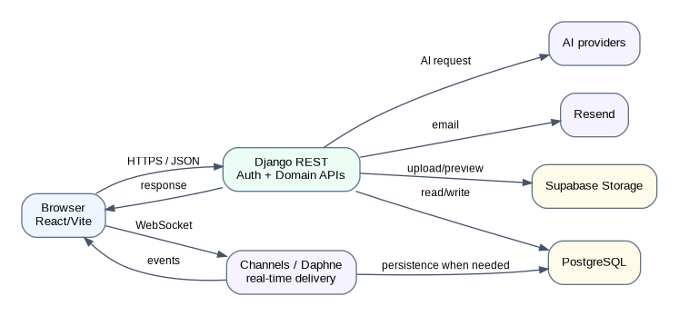

6. Technical Implementation

6.1 Backend Organization
The backend is structured as a Django project with domain-oriented apps. This design keeps authentication, academic productivity, resources, AI processing, communication, notifications, search and administration logically separate while sharing the same application and database context.
backend/
├── apps/
│ ├── accounts/ # users, roles, authentication, profile, preferences
│ ├── administration/ # admin dashboard, controls, moderation, analytics, audit
│ ├── ai_lab/ # AI documents, parsing, summaries, quizzes, chat, logs
│ ├── communication/ # friends, conversations, messages, attachments
│ ├── courses/ # dashboard/course-level endpoints
│ ├── notification/ # notifications and announcements
│ ├── resources/ # Vault, uploads, metadata, storage, moderation
│ ├── search/ # normal-user global search
│ └── tasks/ # tasks, study sessions, routine and task analytics
├── core/
│ ├── settings.py
│ ├── urls.py
│ ├── asgi.py
│ └── wsgi.py
├── manage.py
├── requirements.txt
└── .env.example

6.1.1 Backend Domain Responsibilities
App | Responsibility
accounts | Custom user model, roles, authentication, registration, password reset, profile, preferences, account status and admin role metadata.
courses | Student dashboard and course-level endpoints.
tasks | Tasks, study sessions, routine-related productivity data and task analytics.
resources | Vault courses, uploaded resources, resource metadata, moderation state, sharing controls and storage tracking.
ai_lab | AI study documents, parsing, summaries, quizzes, MCQs, document chat, provider fallback logic and AI logs.
communication | Friend requests, friends, conversations, group chats, messages, attachments and communication restrictions.
notification | Notifications, system announcements, unread state and read tracking.
search | Application-wide search for normal-user content.
administration | Admin dashboard, user/resource/AI/communication controls, announcements, analytics, settings, reports and audit logs.

6.2 RESTful API Overview
Module | Method / Group | Endpoint | Purpose / Evidence
Authentication | POST | /api/auth/register/ | Register normal user
Authentication | POST | /api/auth/login/ | Login and receive token
Authentication | POST | /api/auth/password-reset/request/ | Request password reset
Authentication | POST | /api/auth/password-reset/confirm/ | Confirm password reset
Authentication | GET/PATCH | /api/auth/me/ | Read/update current user
Authentication | GET | /api/auth/users/<id>/profile/ | Public profile lookup
Dashboard | GET / group | /api/app/dashboard/ | Normal-user dashboard data
Search | GET / group | /api/app/search/ | Normal-user application search
Routine | CRUD / group | /api/app/routine/ | Routine slots
Tasks | CRUD / group | /api/app/tasks/ | Tasks and study sessions
Resources | CRUD / group | /api/app/resources/ | Vault courses and resources
AI Lab | CRUD / group | /api/app/ai-lab/ | AI documents, summary, quiz and chat
Communication | CRUD / group | /api/app/communication/ | Friends, requests, conversations and messages
Notifications | GET/PATCH / group | /api/app/notification/ | Notifications and read state
Admin overview | GET | /api/admin-panel/overview/ | Administration metrics
Admin users | CRUD | /api/admin-panel/users/ | User management
Admin user action | PATCH / group | /api/admin-panel/users/<id>/ | User updates and admin actions
Admin resources | CRUD / moderation | /api/admin-panel/resources/ | Course/resource monitoring
Admin resource action | PATCH / group | /api/admin-panel/resources/<id>/ | Resource moderation
Admin AI | GET / control | /api/admin-panel/ai/ | AI usage and logs
Admin AI document | PATCH / group | /api/admin-panel/ai/documents/<id>/ | AI document controls
Admin communication | GET / control | /api/admin-panel/communication/ | Communication reports
Admin conversation | PATCH / group | /api/admin-panel/communication/conversations/<id>/ | Conversation moderation
Admin message | PATCH / group | /api/admin-panel/communication/messages/<id>/ | Message moderation
Admin moderation | GET / control | /api/admin-panel/moderation/ | Report queue
Admin report | PATCH / group | /api/admin-panel/moderation/reports/<id>/ | Review report actions
Admin tasks/routine | GET | /api/admin-panel/tasks-routine/ | Aggregate oversight
Admin notifications | CRUD / group | /api/admin-panel/notifications/ | Announcements and templates
Admin settings | GET/PATCH | /api/admin-panel/settings/ | System settings
Admin audit | GET | /api/admin-panel/audit-logs/ | Audit logs

6.3 WebSocket / Real-Time Layer
Django Channels and Daphne are part of the documented backend stack. The public README does not expose a complete event-name or routing contract, so this report does not invent channel identifiers. Functionally, the real-time layer supports the platform’s communication architecture and can be combined with persisted message/notification records so that live events and durable history remain separate concerns.
Concern | Documented Role | Implementation Detail Available Publicly
Connection lifecycle | Real-time client/server communication | Framework stack documented; exact event names not listed.
Messages | Live delivery between communication participants | Communication module documented; exact websocket payload schema not listed.
Notifications | Immediate UI updates can complement persisted records | Notification module documented; exact websocket event schema not listed.
ASGI runtime | Daphne can serve Channels-enabled backend | Explicit README command is provided.
Verification | Open chat and smoke-test routes are suggested in README | No automated websocket test report is published.

6.4 AI Processing Pipeline
The AI Lab is one of the main distinguishing technical subsystems. The repository lists file-parsing libraries for PDF, DOCX, PPTX and XLSX content, OCR through pytesseract, HTML parsing via BeautifulSoup, and configurable AI providers through Groq/OpenRouter settings. The project description also emphasizes decoupled/async AI processing so large document tasks do not unnecessarily block the UI.
Figure 13: AI study material processing and generation pipeline.

6.5 Role-Based Access Control (RBAC)
Role / Class | Workspace | Key Permissions | Restricted Actions
Normal User | Student workspace | Dashboard, routine, tasks, Vault, AI Lab, communication, notifications, profile, settings | All admin routes and admin APIs
is_staff | Administrative access class | Admin workspace and administrator capabilities according to application policy | Normal-user communication features are intentionally restricted for admin accounts
is_superuser | Highest Django administrative class | Administrative workspace and high-level controls | Normal communication APIs
support_admin | Application admin role metadata | Support/operations administration as configured | Actions outside assigned policy
moderator | Application admin role metadata | Moderation/report workflows as configured | Unrelated privileged functions
super_admin | Application admin role metadata | Broadest application administration | Restricted by platform policy and backend authorization

The communication safety policy is explicit: admin accounts do not appear in friend suggestions or communication search; normal users cannot send friend requests to admin accounts through the API; and admin accounts cannot use normal communication APIs. Normal users are also blocked from admin features at both frontend and backend levels.

6.6 Frontend Organization
frontend/
├── public/
├── src/
│ ├── api/
│ │ ├── adminApi.js
│ │ ├── aiLabApi.js
│ │ ├── authApi.js
│ │ ├── client.js
│ │ ├── communicationApi.js
│ │ ├── dashboardApi.js
│ │ ├── endpoints.js
│ │ ├── notificationApi.js
│ │ ├── resourceApi.js
│ │ ├── routineApi.js
│ │ └── taskApi.js
│ ├── components/
│ │ ├── common/
│ │ └── layout/
│ ├── context/
│ │ ├── AuthContext.jsx
│ │ └── NotificationsContext.jsx
│ ├── features/
│ │ ├── auth/
│ │ ├── normal-user/
│ │ │ ├── ai-tools/
│ │ │ ├── communication/
│ │ │ ├── dashboard/
│ │ │ ├── profile/
│ │ │ ├── resources/
│ │ │ ├── routine/
│ │ │ ├── settings/
│ │ │ └── tasks/
│ │ └── administration/
│ │ ├── admin-panel/
│ │ ├── ai-usage/
│ │ ├── analytics/
│ │ ├── audit-logs/
│ │ ├── communication-reports/
│ │ ├── dashboard/
│ │ ├── notifications/
│ │ ├── resources/
│ │ ├── system-settings/
│ │ ├── tasks-routine/
│ │ └── users/
│ ├── hooks/
│ ├── layouts/
│ ├── routes/
│ ├── styles/
│ ├── App.jsx
│ └── main.jsx
└── package.json

6.7 Environment Configuration
Variable | Purpose | Source Status
SECRET_KEY | Django secret key | Documented in .env.example
DEBUG | Django debug mode | Documented
ALLOWED_HOSTS | Backend host allow-list | Documented
GROQ_API_KEY | Groq authentication | Documented
OPENROUTER_API_KEY | OpenRouter authentication | Documented
GROQ_MODEL | Groq model selection | Documented
OPENROUTER_MODELS | Fallback/available OpenRouter models | Documented
OPENROUTER_SITE_URL | OpenRouter request metadata | Documented
OPENROUTER_APP_NAME | Application metadata | Documented
FRONTEND_URL | Frontend origin / application URL | Documented
RESEND_API_KEY | Email service key | Documented
RESEND_FROM_EMAIL | Email sender address | Documented
SUPABASE_URL | Supabase project URL | Documented
SUPABASE_KEY | Supabase API key | Documented
SUPABASE_MEDIA_BUCKET | Media bucket name | Documented
VITE_API_BASE_URL | Frontend API base URL | Documented

6.8 Deployment and Runtime Notes
- The repository advertises a Vercel-hosted frontend at scholarscanvas.vercel.app.
- A render.yaml file is present in the repository, indicating deployment configuration is included in the project repository.
- The README documents local Django on port 8000, Django admin at /admin/, Vite on port 5173, and an optional Daphne/ASGI run mode.
- Python 3.11+, Node.js 20+, PostgreSQL, Tesseract (when OCR is needed), Supabase media storage and AI provider keys are listed as prerequisites.
- The README notes that direct storage/file URL handling should be reconsidered or supplemented before making an entire storage bucket private.

7. Quality Assurance & Testing
This chapter follows the template’s test-case and requirements-traceability structure, but it is deliberately evidence-aware. The public README provides explicit verification commands—Django system check, frontend production build, and several route smoke checks—but it does not publish a complete automated test suite or pass/fail execution report. Therefore the test matrix below defines the verification plan and expected outcomes; “Documented procedure” is used where the repository explicitly describes the check, while “Manual verification required” is used for feature behavior without published execution evidence.

7.1 Documented Verification Procedures
Backend system check
cd backend
python manage.py check
Frontend build verification
cd frontend
npm run build
Common route smoke checks
/
/tasks
/admin
/admin/users
/admin/settings

7.2 Test Case Scenarios
Test ID | Test | Input / Action | Expected Result | Evidence Status
TC01 | Registration | Valid university profile information | Account is created and can authenticate | Manual verification required
TC02 | Duplicate/invalid registration | Existing email or invalid input | Validation message is shown and account state is unchanged | Manual verification required
TC03 | Login success | Valid credentials | Token is issued and correct workspace is loaded | Manual verification required
TC04 | Wrong credentials | Invalid password | Authentication fails without entering protected workspace | Manual verification required
TC05 | Role routing | Normal user vs admin account | Normal user enters student workspace; admin enters admin workspace | Manual verification required
TC06 | Unauthorized admin route | Normal user requests /admin | Route/API is rejected or redirected | Documented behavior; execution not published
TC07 | Password reset request | Valid account email | Reset request is accepted and confirmation flow is available | Manual verification required
TC08 | Password reset confirmation | Valid reset token/new password | Password is updated and old credentials stop working | Manual verification required
TC09 | Routine create/update/delete | Valid routine slot | Slot is persisted and reflected in views | Manual verification required
TC10 | Task create | Title, course, deadline, priority | Task appears in list/Kanban and dashboard state | Manual verification required
TC11 | Study session | Valid start/end or study interval | Session is stored and contributes to analytics | Manual verification required
TC12 | Course creation | Valid course metadata | Course workspace becomes available | Manual verification required
TC13 | Resource upload | Allowed file type within configured limit | Resource is stored with metadata | Manual verification required
TC14 | Resource validation | Disallowed extension or oversized upload | Upload is rejected with clear feedback | Manual verification required
TC15 | Resource preview | Existing resource | Authorized user can preview/open the resource | Documented by development notes; execution not published
TC16 | Vault-to-AI handoff | Existing resource selected for AI | AI document is created/queued for processing | Manual verification required
TC17 | Direct AI document upload | Supported study file | AI document is processed or status is shown | Manual verification required
TC18 | AI summary | Processed document | Summary is generated and displayed | Manual verification required
TC19 | AI quiz | Processed document | Quiz is generated | Manual verification required
TC20 | AI MCQ | Processed document | MCQs are generated | Manual verification required
TC21 | Document chat | Question over selected document | Response is generated using selected study material context | Manual verification required
TC22 | AI failure handling | Provider failure or invalid content | Failure is surfaced and logged; fallback/retry path is used when available | Manual verification required
TC23 | User search | Normal student search query | Only permitted normal-user results are returned | Manual verification required
TC24 | Friend request lifecycle | Send/accept/reject/cancel | State changes correctly and recipient is notified as appropriate | Manual verification required
TC25 | Conversation creation | Friends only | Eligible users can create 1:1/group conversation; restricted accounts are excluded | Manual verification required
TC26 | Message send/edit/unsend | Text/file message | Message is persisted and state changes follow rules | Manual verification required
TC27 | Admin exclusion from communication | Admin account search/friend request | Admin accounts are hidden from communication features and API blocks attempts | Documented behavior; execution not published
TC28 | Notification read state | Unread notification opened | Unread count/read state is updated | Manual verification required
TC29 | System announcement | Admin sends system-wide announcement | Target users receive notification | Manual verification required
TC30 | Targeted announcement | University/department/semester target | Only matching users receive announcement | Manual verification required
TC31 | Admin user management | Search/update/suspend/unsuspend | User record/control state changes and access is enforced | Manual verification required
TC32 | Admin resource moderation | Flag/remove/restore/revoke | Resource moderation state changes correctly | Manual verification required
TC33 | Communication moderation | Disable conversation / remove message | Moderation decision takes effect | Manual verification required
TC34 | Moderation report | Resolve or dismiss report | Report state is updated and audit context is retained | Manual verification required
TC35 | Analytics dashboard | Admin opens analytics | Usage/storage/AI/weekly metrics load | Manual verification required
TC36 | System settings | Change upload/AI/rate/group settings | New configuration is persisted and applied | Manual verification required
TC37 | Audit logging | Admin or security action | Actor, role, action, target and timestamp are recorded | Documented behavior; execution not published
TC38 | Aggregate task/routine oversight | Admin opens overview | Aggregate statistics display without exposing personal task content by default | Manual verification required
TC39 | Django system check | python manage.py check | Django reports no system-check errors | Documented procedure
TC40 | Frontend build | npm run build | Production bundle is generated successfully | Documented procedure
TC41 | Route smoke checks | /, /tasks, /admin, /admin/users, /admin/settings | Routes load according to authorization state | Documented procedure
TC42 | Responsive interaction | Mobile/tablet/desktop browser sizes | Layout remains usable and feature controls remain accessible | Manual verification required

7.3 Requirements Traceability Matrix (RTM)
FR Group | Feature | Test IDs | Coverage | Source Basis | Status
FR01–FR05 | Authentication & access | TC01–TC08 | Registration, login, reset, role routing | Planned + documented behavior | Verification required
FR06–FR09 | Dashboard, routine, tasks, sessions | TC09–TC11 | Planning and productivity lifecycle | Feature documented | Verification required
FR10–FR12 | Courses and Vault | TC12–TC15 | Course/resource management | Feature documented | Verification required
FR13–FR18 | AI Lab and AI administration | TC16–TC22, TC35–TC36 | AI intake, generation, logs and controls | Feature documented | Verification required
FR19–FR23 | Communication | TC23–TC27 | Search, friends, conversations and messages | Feature documented | Verification required
FR24–FR26 | Notifications and search | TC28–TC30, TC41 | Read state, announcements, command/search routing | Feature documented | Verification required
FR27–FR30 | Administration and moderation | TC31–TC34 | Users, resources, communication, reports | Feature documented | Verification required
FR31–FR34 | Analytics, settings, audit, privacy | TC35–TC38 | Management and oversight | Feature documented | Verification required
FR35 | Workspace access control | TC05–TC07, TC27, TC41 | Frontend/backend boundary enforcement | Explicit in README | Verification required

7.4 QA Findings and Improvement Recommendations
- No automated test suite or test execution report is published in the repository snapshot reviewed. A stronger capstone submission should include backend unit/API tests, frontend component tests where practical, and at least one end-to-end smoke suite.
- The documented verification commands are valuable but should be turned into repeatable CI checks so future changes cannot silently break core routes or builds.
- AI integrations should be tested with provider failures, rate limiting, malformed documents and large files so fallback behavior is observable rather than assumed.
- Communication features should have explicit authorization tests proving that admin accounts cannot enter normal communication APIs and that normal users cannot access admin endpoints.
- Resource storage privacy should be reviewed before production hardening because the README itself notes a need to reconsider direct storage/file URL exposure when a bucket is made private.

8. Individual Contribution
Name | Student ID | Role | Contribution
MD. Shoaib Sikder | 024231005341157 | Project Lead / Full-Stack Developer | Project conception, system architecture, Django backend, REST API design, React/Vite frontend architecture, AI Lab integration, resource workflows, authentication/RBAC, communication and admin workspace implementation, UI refinement, deployment/setup documentation, testing and documentation. The repository/Devpost describe Scholars Canvas as a solo project.

8.1 Technical Challenges
- Designing two distinct workspaces without duplicating the application shell and routing logic.
- Keeping AI document processing responsive while handling multiple file formats and optional OCR.
- Maintaining strict communication rules so administrator accounts remain isolated from normal student social features.
- Coordinating persistent data, external storage, AI providers, email delivery and application settings in one modular architecture.
- Keeping the frontend domain structure aligned with backend API groups as the platform grew in feature count.

8.2 Learning Outcomes
- Practical experience designing a modular Django REST architecture and a feature-oriented React frontend.
- Hands-on understanding of authentication, role-based authorization and protected routing across frontend and backend layers.
- Experience integrating external AI, storage and email services while keeping their configuration outside core application logic.
- Improved understanding of document processing pipelines, OCR and AI-grounded study workflows.
- Practical experience designing administrative moderation, analytics and audit mechanisms rather than treating admin as a simple CRUD screen.
- Experience using AI coding assistants such as Codex/GPT-5.6 as development companions while retaining responsibility for architecture, implementation and verification.

8.3 Development Assistance Disclosure
The public project README states that Codex and GPT-5.6 were used as practical development companions for planning, implementation patterns, debugging, UI/UX brainstorming, architecture refinement and documentation. This report therefore treats the application as the author’s project while transparently documenting the role of AI-assisted development.

9. Conclusion & Future Work

9.1 Conclusion
Scholars Canvas demonstrates a broad Software Engineering solution to a real student productivity problem by combining academic planning, resource management, AI-assisted study, communication and platform administration in a unified architecture. The design is intentionally modular: Django apps separate core responsibilities, while the React frontend uses domain-based feature folders and shared application infrastructure. The system also treats administrative control as a first-class requirement rather than an afterthought, providing explicit management surfaces for users, resources, AI usage, communication, reports, announcements, settings, analytics and audit logs.
The project’s strongest engineering characteristics are its separation of concerns, explicit role boundaries, configurable external integrations and the connection between resources and AI study workflows. The main area requiring additional evidence for a production-grade claim is formal verification: the public repository documents smoke checks and build checks but does not publish complete automated test coverage or a repeatable test report. Adding that evidence would materially strengthen the project as an academic Software Engineering submission.

9.2 Future Enhancements (Version 2.0)
Enhancement | Description
Collaborative Course Vaults | Allow students to share curated resource collections within controlled groups.
Group Project Hubs | Add team workspaces with roles, shared tasks, files, deadlines and discussion.
PWA / Offline Mode | Enable limited offline access to routines, tasks and selected resources.
External Drive Sync | Integrate Google Drive/Dropbox-style import and synchronization for study files.
Advanced Study Analytics | Add study velocity, consistency trends, workload forecasting and deadline risk indicators.
Institutional Integration | Connect with university course catalogs, semester data and potentially official schedules through authenticated APIs.
AI Evaluation Layer | Track answer quality, citation/grounding indicators, generation latency and user feedback.
Automated Moderation | Add content classification and safety triage before manual admin review.
Automated Test & CI Pipeline | Add unit, integration, API, authorization and end-to-end suites with continuous integration.
Observability & Production Hardening | Centralized error monitoring, metrics, rate-limit telemetry, structured logs and privacy/security reviews.

10. Appendices

Appendix A: Repository and Project Resources
- GitHub repository: https://github.com/ShoaibSikder/Scholars-Canvas
- Live frontend listed by the repository: https://scholarscanvas.vercel.app/
- Project description: https://devpost.com/software/scholars-canvas
- License: GNU Affero General Public License v3.0 (AGPL-3.0).

Appendix B: Backend Setup
# 1. Clone repository
git clone https://github.com/ShoaibSikder/Scholars-Canvas.git
cd Scholars-Canvas/backend
# 2. Create virtual environment
python -m venv venv
# Windows
venv\Scripts\activate
# macOS/Linux
source venv/bin/activate
# 3. Install dependencies
pip install -r requirements.txt
# 4. Create environment configuration
copy .env.example .env
# 5. Apply migrations
python manage.py migrate
# 6. Create administrator account
python manage.py createsuperuser
# 7. Start development server
python manage.py runserver
# Optional ASGI / Channels runtime
python -m daphne core.asgi:application

Default backend URL: http://localhost:8000/ | Django admin: http://localhost:8000/admin/

Appendix C: Frontend Setup
cd frontend
npm install
# Create .env
VITE_API_BASE_URL=http://localhost:8000/api
# Start development server
npm run dev
# Production build
npm run build

Default frontend URL: http://localhost:5173/

Appendix D: Environment Configuration Checklist
Area | Required Configuration
Django | SECRET_KEY, DEBUG, ALLOWED_HOSTS
AI | GROQ_API_KEY, OPENROUTER_API_KEY, model configuration
Email | RESEND_API_KEY, RESEND_FROM_EMAIL
Storage | SUPABASE_URL, SUPABASE_KEY, SUPABASE_MEDIA_BUCKET
Frontend | VITE_API_BASE_URL
Runtime | Python 3.11+, Node 20+, PostgreSQL
OCR | Install Tesseract locally when OCR functionality is required

Appendix E: Route Catalogue
Workspace | Representative Routes | Access
Normal User | /, /routine, /tasks, /vault, /ai-lab, /communication, /profile, /settings | Authenticated normal user
Administration | /admin, /admin/users, /admin/resources, /admin/ai, /admin/communication, /admin/tasks, /admin/notifications, /admin/analytics, /admin/settings, /admin/audit | Authorized admin roles

Appendix F: Source Basis and Evidence Notes
Source 1 - Uploaded template: “Full Project Document.docx”. Used for report organization, academic capstone sectioning, scenario style, requirement tables, architecture/database sections, technical implementation, QA/testing, contribution, conclusion and appendices.
Source 2 - Public Scholars Canvas GitHub repository and README. Used for current project identity, repository structure, features, role model, technology stack, API groups, environment variables, local setup, testing commands and development notes.
Source 3 - Public Scholars Canvas Devpost description. Used to cross-check project positioning, motivation, architecture summary, AI processing emphasis, challenges, accomplishments and future directions.
Evidence policy used in this report: exact facts are stated only where supported by the source material. Where the public README does not expose exact migration field names, websocket event names, or test execution results, the report uses logical/conceptual language instead of presenting invented implementation detail as fact.

Appendix G: Documentation Change / Verification Checklist
Check | Status before final submission
Cover page reviewed | Complete
Table of contents reviewed | Complete
Figures inserted and captioned | Complete
Requirements aligned with documented features | Complete
API overview aligned with README | Complete
RBAC aligned with documented route policy | Complete
Database section labeled as logical where schema is not public | Complete
Testing chapter avoids unsupported “all tests passed” claims | Complete
Setup commands aligned with README | Complete
DOCX render inspection | Pending final automated visual QA

